User Project Data Store Requirements Specification

Scope

Overview
The component provides API to access the TopCoder user and project database in order to integrate with the Online Review application.

Logic Requirements

User Database
Component will provide read only access to the TopCoder user database. Retrieval should be based on either external identifier or user handle. The following information will be retrieved: external identifier, user handle, email, rating and reliability. Rating and reliability are optional and will be per phase (dev/design). A batch mode should be provided as well.

Project Database
Component will provide read only access to the TopCoder project database. Retrieval should be based on either external identifier, or project name/version. The following information will be retrieved: external identifier, project name, version, catalog type (Java/.NET), catalog reference identifier, forum reference identifier. A batch mode should be provided as well.

Required Algorithms
No specific algorithms are required.

Example of the Software Usage
After user is logged into the application, the handle of the logged user will be displayed in the header. The session contains the user’s external identifier. The component can be used to retrieve the user’s handle as well as rating, so that the handle can be rendered in the color corresponding to the user’s rating.

Future Component Direction
None.

Interface Requirements

Graphical User Interface Requirements
None.

External Interfaces
Design must adhere to the interface diagram definition. Designer can choose to add more methods to the classes/interfaces, but must keep the ones defined on the diagram as a minimum. Source files can be found in the distribution.
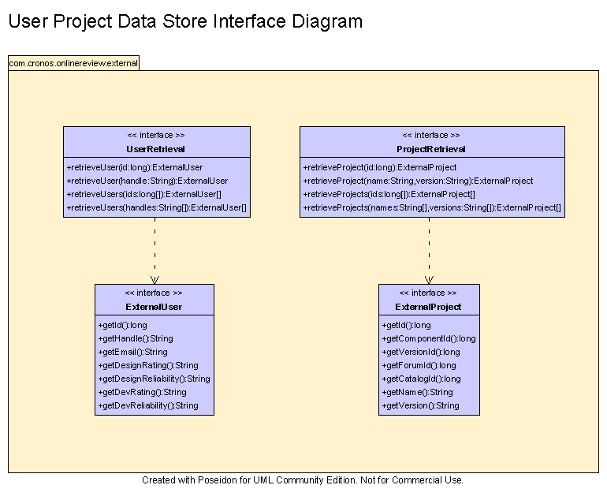

Environment Requirements
- Development language: Java1.4
- Compile target: Java1.4

Package Structure
com.cronos.onlinereview.external

Software Requirements

Administration Requirements

What elements of the application need to be configurable?
- Database connection

Technical Constraints

Are there particular frameworks or standards that are required?
JDBC

TopCoder Software Component Dependencies:
- Configuration Manager
- DB Connection Factory

**Please review the TopCoder Software component catalog for existing components that can be used in the design.

Third Party Component, Library, or Product Dependencies:
None.

QA Environment:
- Solaris 7
- RedHat Linux 7.1
- Windows 2000
- Windows 2003
- Informix 10.0

Design Constraints
The component design and development solutions must adhere to the guidelines as outlined in the TopCoder Software Component Guidelines.

Database Connections
Database connections must not be cached within the component. Connections should be created for each operation and closed afterwards.

Component Scalability
The component needs to be scalable. Running multiple instances in the same JVM or in multiple JVM’s concurrently should not cause any problem.

Required Documentation

Design Documentation
- Use-Case Diagram
- Class Diagram
- Sequence Diagram
- Component Specification

Help / User Documentation
- Design documents must clearly define intended component usage in the ‘Documentation’ tab of Poseidon.

